Howden Town Council

27 June 2017

A Special meeting of Howden Town Council will be held on Tuesday 4 July 2017 at 7 pm in the Town Council meeting room, 17 Bridgegate, Howden, to transact the business specified below.
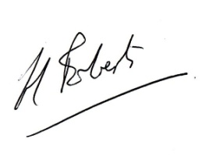

Councillor Hugh Roberts
Chair of the Council

AGENDA

Howden Town Council, Tuesday 4 July 2017 at
7 pm in the Town Council meeting room, 17 Bridgegate, Howden

- Apologies for absence: to receive and accept
- Declaration of interest –
2.1 Declarations of Interests, in respect to Agenda items, to be made and recorded in the minutes even if an interest has been declared in the register.
2.2 For the Council to note any dispensations presented to the Clerk prior to the Meeting and their resolution.
3. 17/01720/STPLF: Erection of 300 dwellings with associated access, open space, landscaping and infrastructure at Land North Of Selby Road, Howden – To formally approve draft comments.

